Test Plan - Group 16

“A document listing game or player actions that need to be tested as well as their expected actions. This test plan will be modified throughout the project as new functionality is added to the game. Make sure that your document clearly labels each milestone.”

Milestone 1

Milestone 2

Milestone 3

| **Action/Test Item** | **Expected Result** |
| --- | --- |
| **Game Controls** | |
| W Key | Move up |
| A Key | Move left |
| S Key | Move down |
| D Key | Move right |
| F Key | Interactions (Picking up items, Enter/Leave Grotto) You must be beside the object to interact |
| R Key | Open or close the recipe book menu |
| L Key | Fully restart the game with no items or inventory persisted, and tutorial also restarts |
| Esc | Exit game |
| T Key | Toggle tutorial on and off, starts off at welcome screen |
| N Key | Skips to next step of tutorial |
| Left Click | Select an inventory slot, throw a throwable potion in the direction of where the mouse cursor is provided the potion is already selected in inventory |
| Shift + Left Click | Performing this action on an inventory slot will delete that item from your inventory |
| Right click | Consume a **consumable** potion (healing, speed). Must be clicked on the potion item in the inventory. |
| Number Keys 1-9 | Select inventory slot |
| Mouse Scroll | Switch between inventory slots |
| Left Click and Drag | Interact with potion making menu, moving the ladle, adjusting heat knob, stirring the cauldron, grinding items in the mortar and pestle |
| P Key | Saves the current game state |
| **Game Mechanics** | |
| Item Collection and Respawn | Find a gale fruit (orange and grows on trees) or a swift bean (brown and grows on bushes), press F to pick it up. Item should disappear, then after 10-15 seconds, it will respawn in the same location. Re-entering a biome will immediate respawn the item. |
| Textbox Visibility | Textbox will appear/disappear when the player is close/far away to an item. Textbox will disappear after the item is picked up. After item respawn, the textbox should be restored too. |
| Collisions | * Player can walk across the bridge, and can move around the shape of the bridge with mesh based collision detection * Player cannot exit the bounds of the game or into rivers. * Player cannot walk through the tree trunk, but can walk through and behind the leaves. * Player collides with various objects in the grotto. * Enemies collides with the same terrain items as the player * Player now slides along the axis to make movement smoother |
| Biome Switching | Interact with an entrance/exit - the screen should fade while maintaining the same background, and the screen will fade back in with the player in the new biome. Character movement should not be possible during this process, essentially the screen should be frozen. Enemy and ammo movement are also frozen |
| Combat | * When the player has selected an ammo item (fruit) in the inventory, they can left click to throw the ammo in that direction. The player has a max throw radius as well as a throwing cooldown of 1 second. Throwing one ammo will remove one count of the item from inventory. * Enemies have a set health and ammo has a set damage. On ammo-enemy collision, the ammo will disappear and the enemy’s health will drop by the amount of the ammo’s damage. If the enemy’s health drops to 0 or below, it will also disappear and a collectable enemy drop will be created at the same position. * If player collides with the enemy, the game will restart * Ingredients are no longer throwable as this was just a proof of the throwing concept in previous milestones since potions were not yet ready. Only certain potions are throwable. |
| Potion Making | * Follow the tutorial for potion making * Star quality is as follows: |
| Tutorial | There are different steps of the tutorial to guide the player upon starting a game (see suggested game test plan). Completion of one step will trigger the next step’s text box. Pressing T will toggle the tutorial on and off, defaults to on. Pressing N will skip to the next tutorial step. |
| Data Persistence | Items in the player inventory, biome state, game progression ect. will automatically be persisted for next game loads.  Added versioning for game state files  The player’s state, active effects, and position are also serialized. The game autosaves every 60 seconds. |
| Enemy AI | * Enemy behaviour uses decision tree logic with four states: Attack, Wander, Return, and Idle. * Collision handling to prevent enemies from getting stuck. * State transitions:   + Attack: Enemy chases when the player enters detection range.   + Wander: If the player escapes, the enemy moves randomly for a short time.   + Return: After wandering, the enemy moves back to its spawn point.   + Idle: Once back, the enemy stays still until the player enters range again. |
| Mortar and Pestle | * One item can be placed in the bowl at a time * Upon using the pestle to grind the item in a quick up and down movement multiple times will convert the item into a powder/grinded entity which can be picked up from the bowl. |
| Potion Usage | * The following potions are throwable and deal damage based on their effect.   + Harming, Molotov Cocktail, Poison, Alkalescence, Clarity, and Failed (only throwable, deals 0 damage) * Ammo can collide into terrain, essentially losing the potion if the player does not aim correctly. * The following potions are consumable and add effects to the player:   + Speed, health (instant), regen, resistance, saturation   + Upon consumption, this will be added to the player’s active effects which can be viewed on the top right box.   + Upon expiry, the player’s specific attribute will return to normal and the indicator will disappear from the box. * Tenacity potion can be made but has yet to be implemented so cannot be thrown or consumed * Higher quality potions deal more damage or have a longer duration/effect. |

Suggested Game Test Plan:

1. Ensure that you run the game with the instructions in the README
2. You should spawn inside the grotto, with the tutorial steps provided. There is an FPS counter in the game window title, an inventory bar on the bottom, and a health bar on the bottom right side of the screen.
   1. 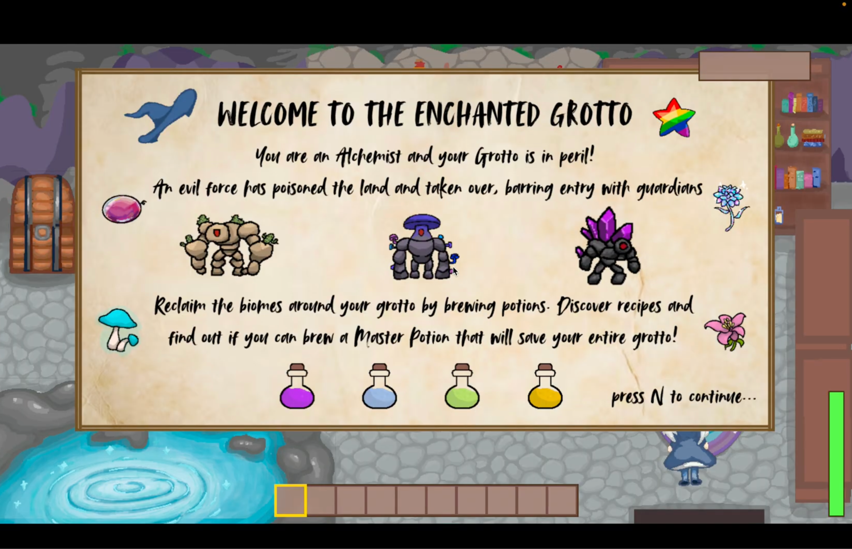

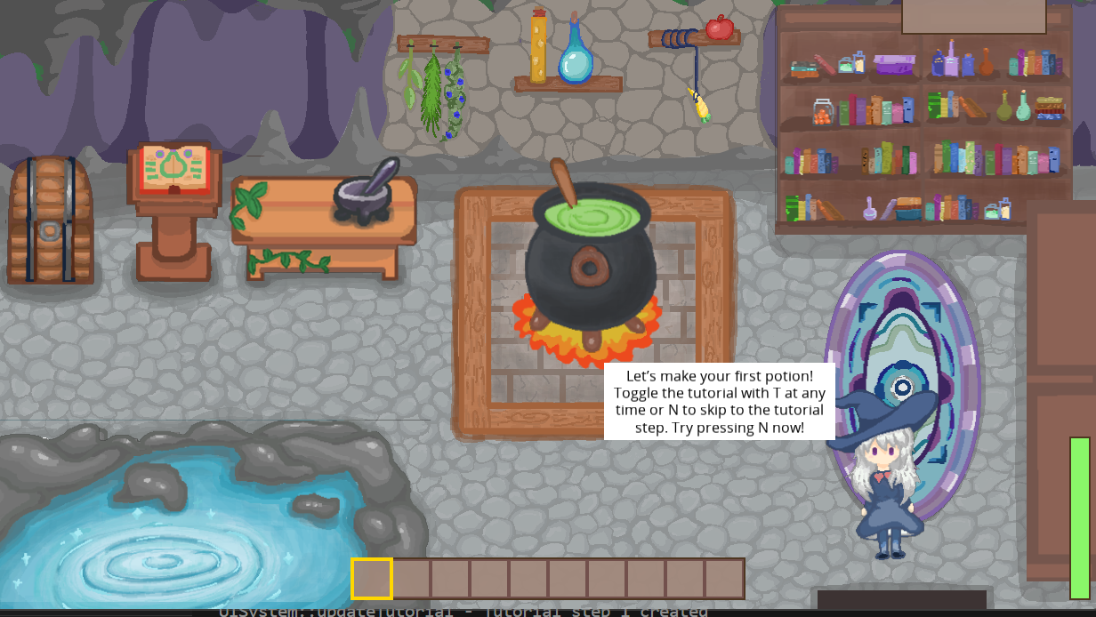

1. Use the WASD keys to move around, follow the instructions in the tutorial and explore inside the grotto. Go to the lectern to read the Recipe Book, and flip to the correct page about Potion of Harming as per the tutorial.

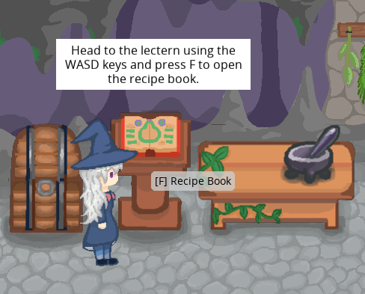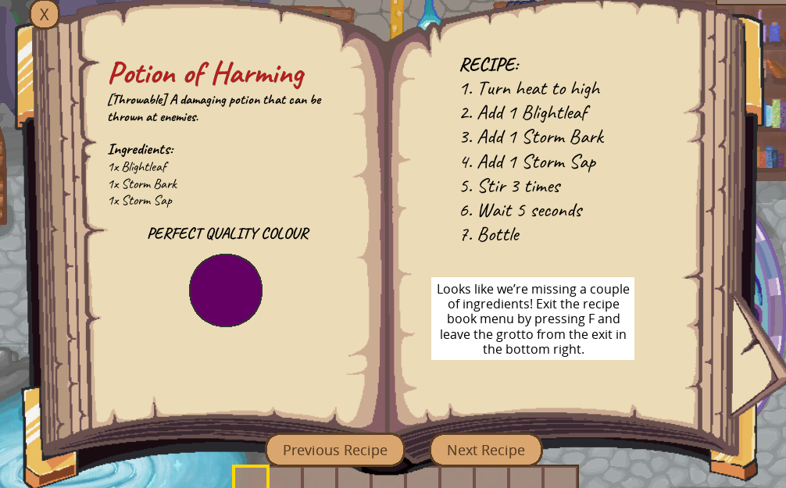

1. Notice we are missing ingredients, go to the door and press F to exit the grotto.
2. Use the WASD keys to move to the trees on the left and bottom. You should see a textbox with “F to interact” appear when you are next to a tree with a fruit on it.

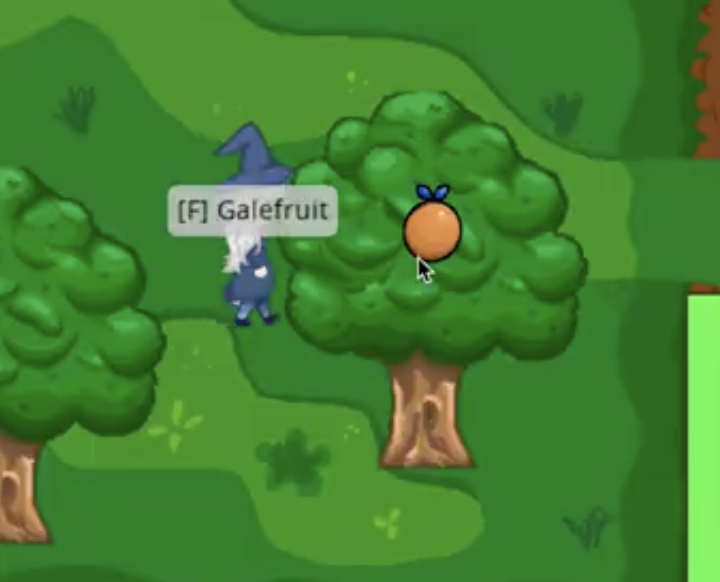

1. Press F to collect fruit on trees. Fruit will respawn after a random time.
2. Notice how the collision handling allows the user to walk behind and in front of the tree as the rendering layers update.

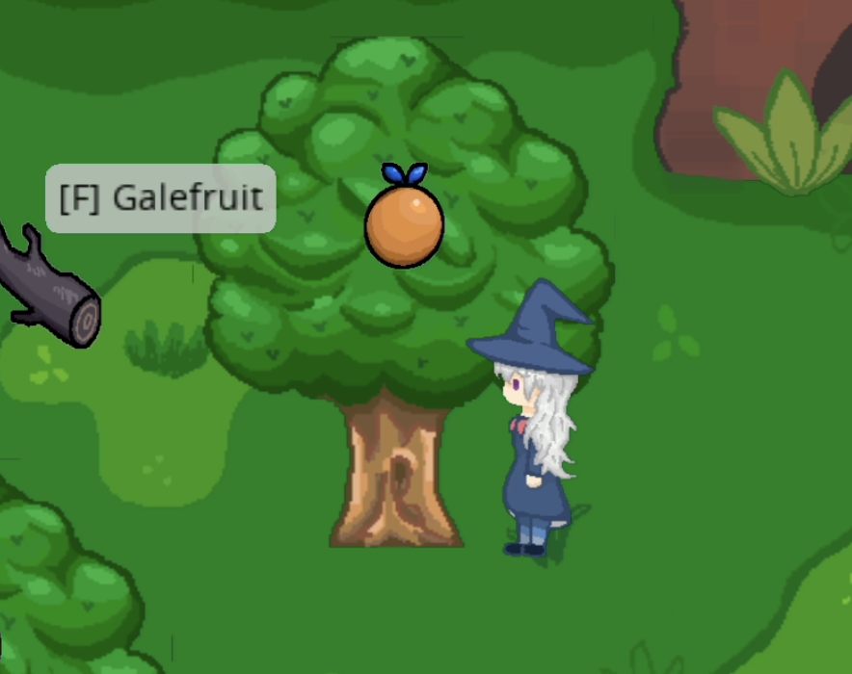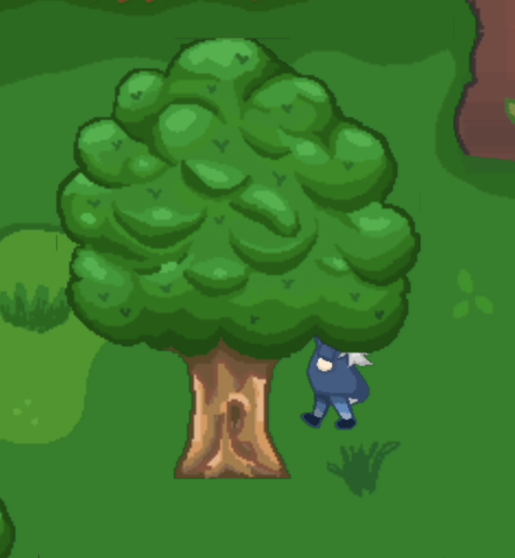

1. The tutorial requires you to pick up 2 Storm Barks for the Potion of Harming - make sure to pick up those Storm Barks by pressing F like how you obtained Galefruit.

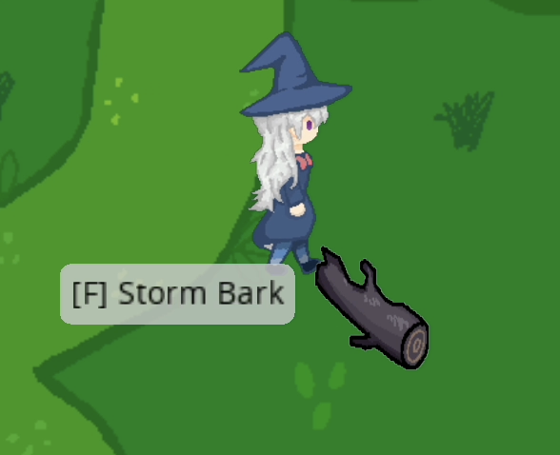

1. Enter the deep forest and avoid being detected by the tree enemies. Collect the Blightleaf in a similar manner.

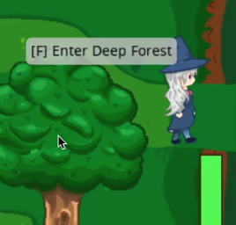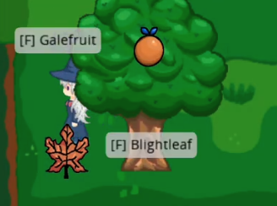

1. Return to the grotto and open the mortar and pestle menu by pressing F.

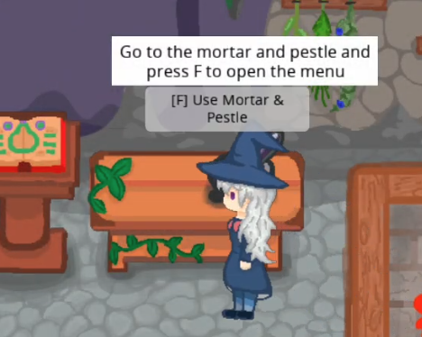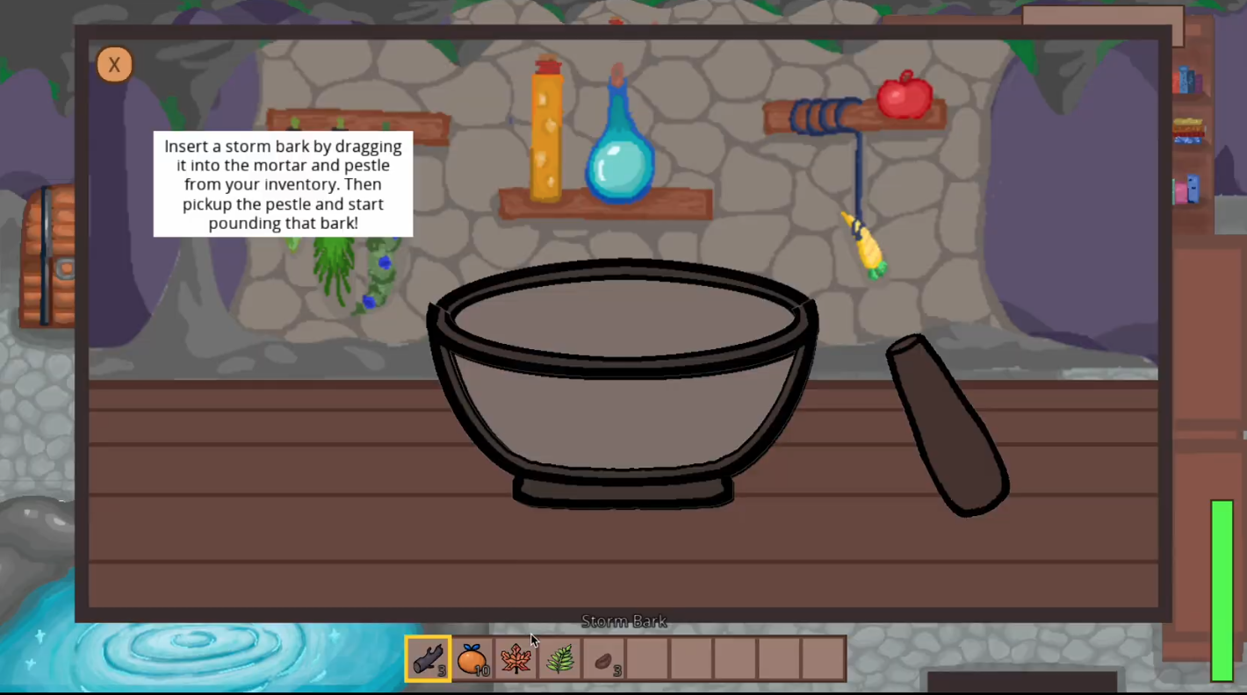

1. Click and drag a single storm bark to the bowl.

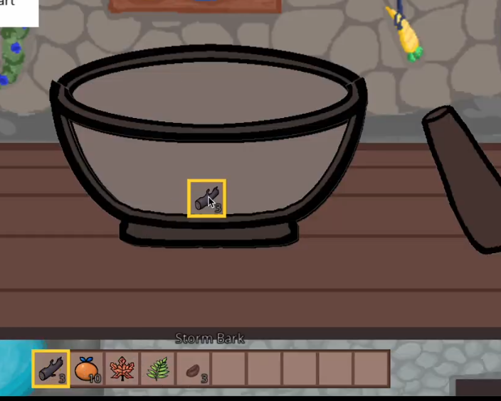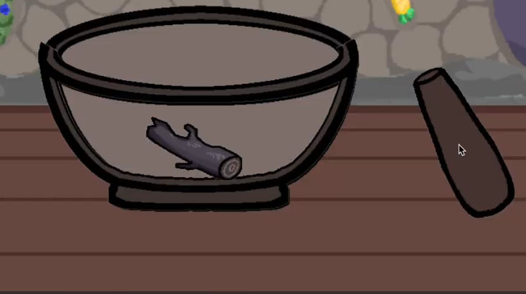

1. Pick up the pestle by clicking it and drag it to above the bowl then quickly bring it down and back up multiple times in a crushing motion to grind the storm bark until it turns into storm sap.

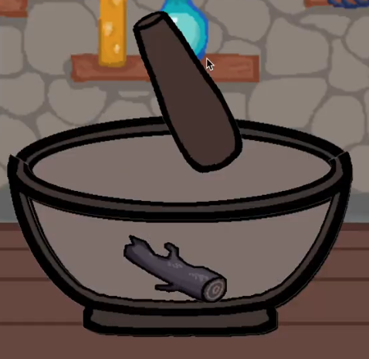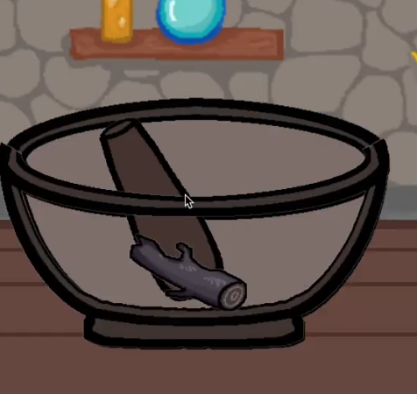

1. When it turns into storm sap, drop the pestle back on the table and click on the storm sap to add it to inventory.

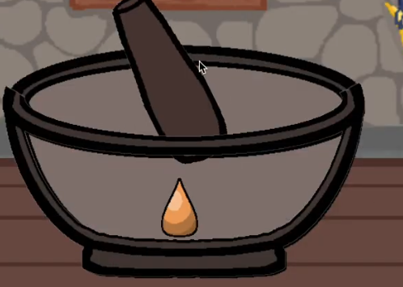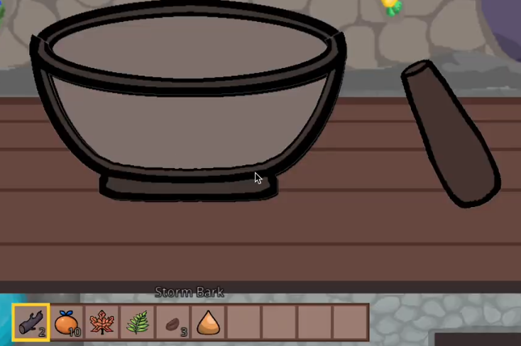

1. Close the mortar and pestle menu by pressing F and walk over to the cauldron and open the cauldron menu by pressing F in front of the cauldron

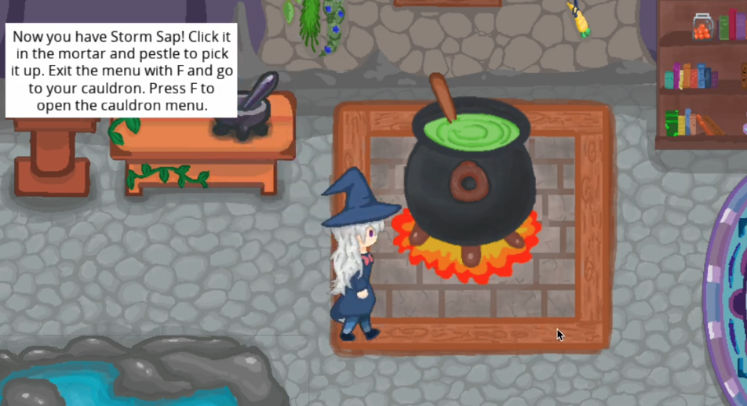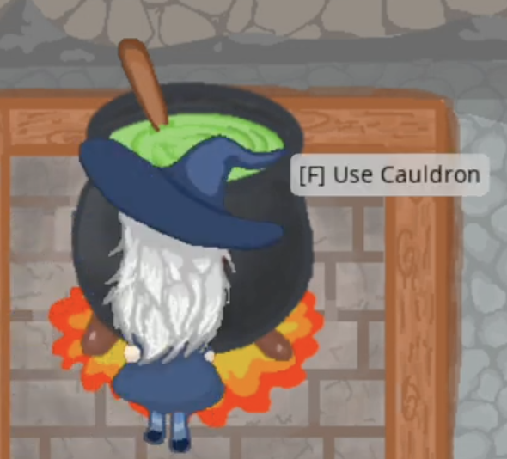

1. Follow the tutorial to make the potion of harming, you can use the “R” key to pull up the recipe book at any time. Start by turning the heat dial to high by holding the left click and dragging the hand on the dial. The water physics simulation should change its speed depending on the heat setting (faster fluid on high, slower fluid on low heat)



1. Then add in the ingredients blightleaf, storm bark and storm sap by dragging the items from your inventory into the cauldron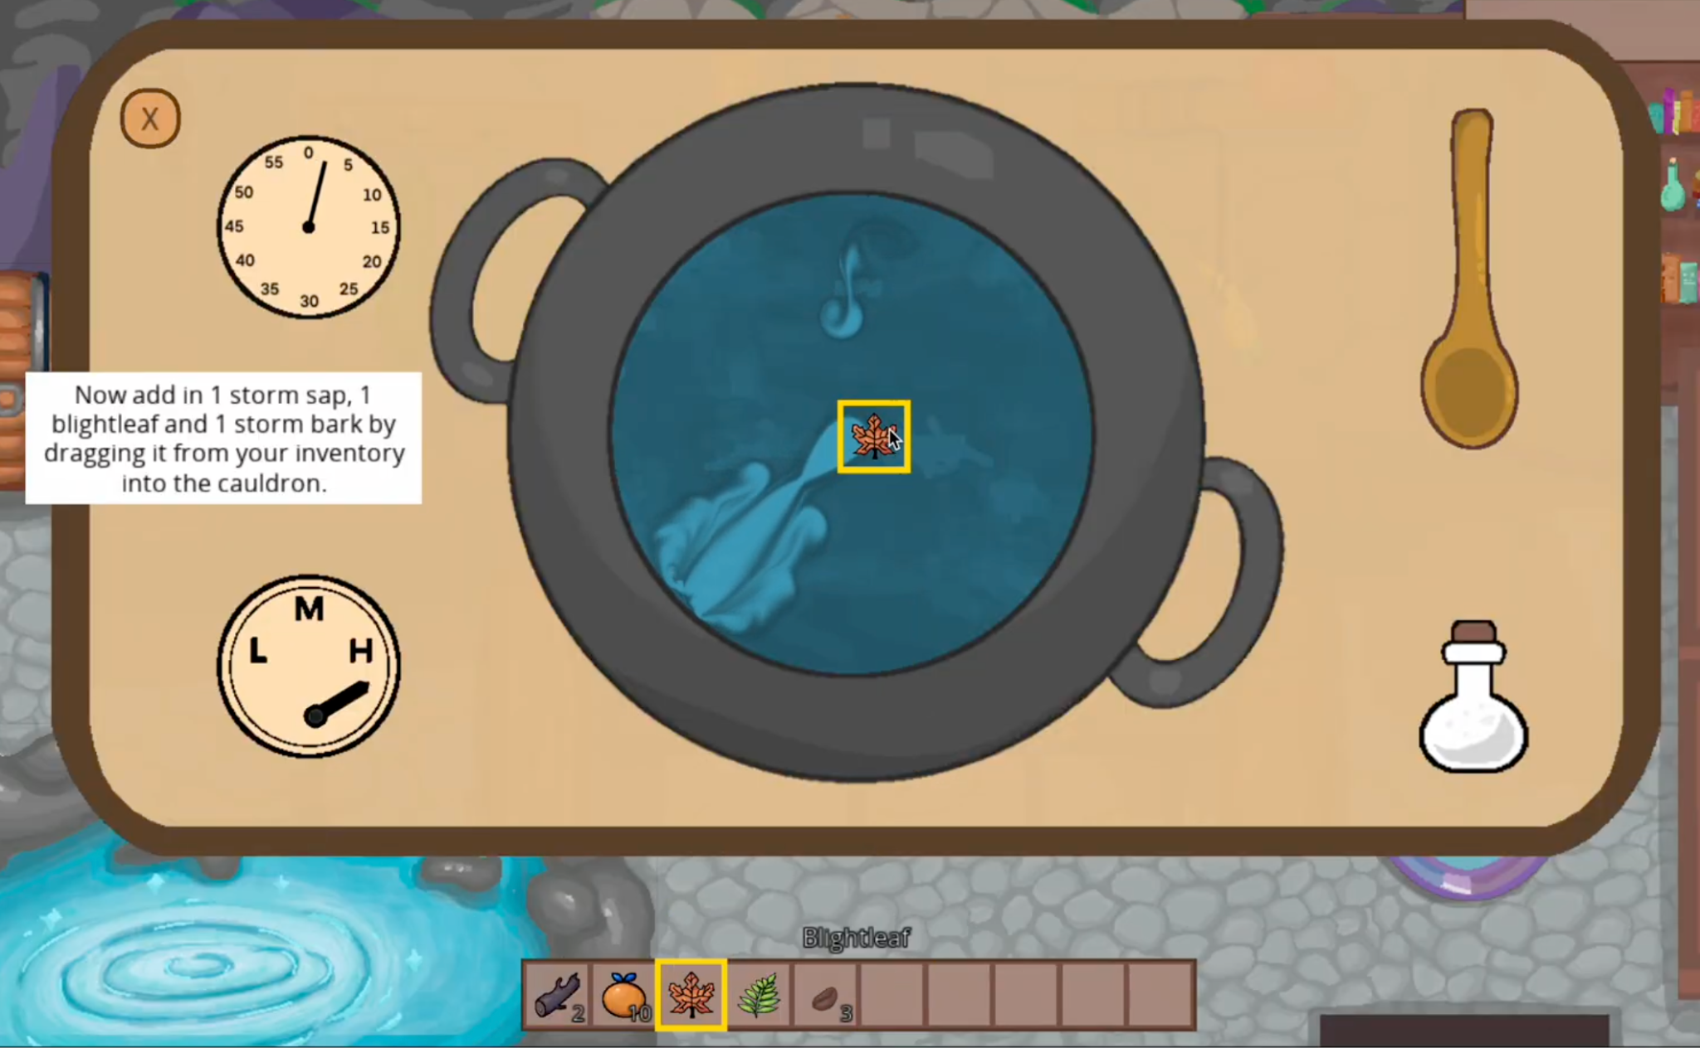
2. Then pick up the ladle with a left click, then let go and now hold the left click again **inside** of the cauldron to stir 3 times, go slow and do a nice big circle. You can see when a stir is successful if there is a whoosh and flash of the cauldron water.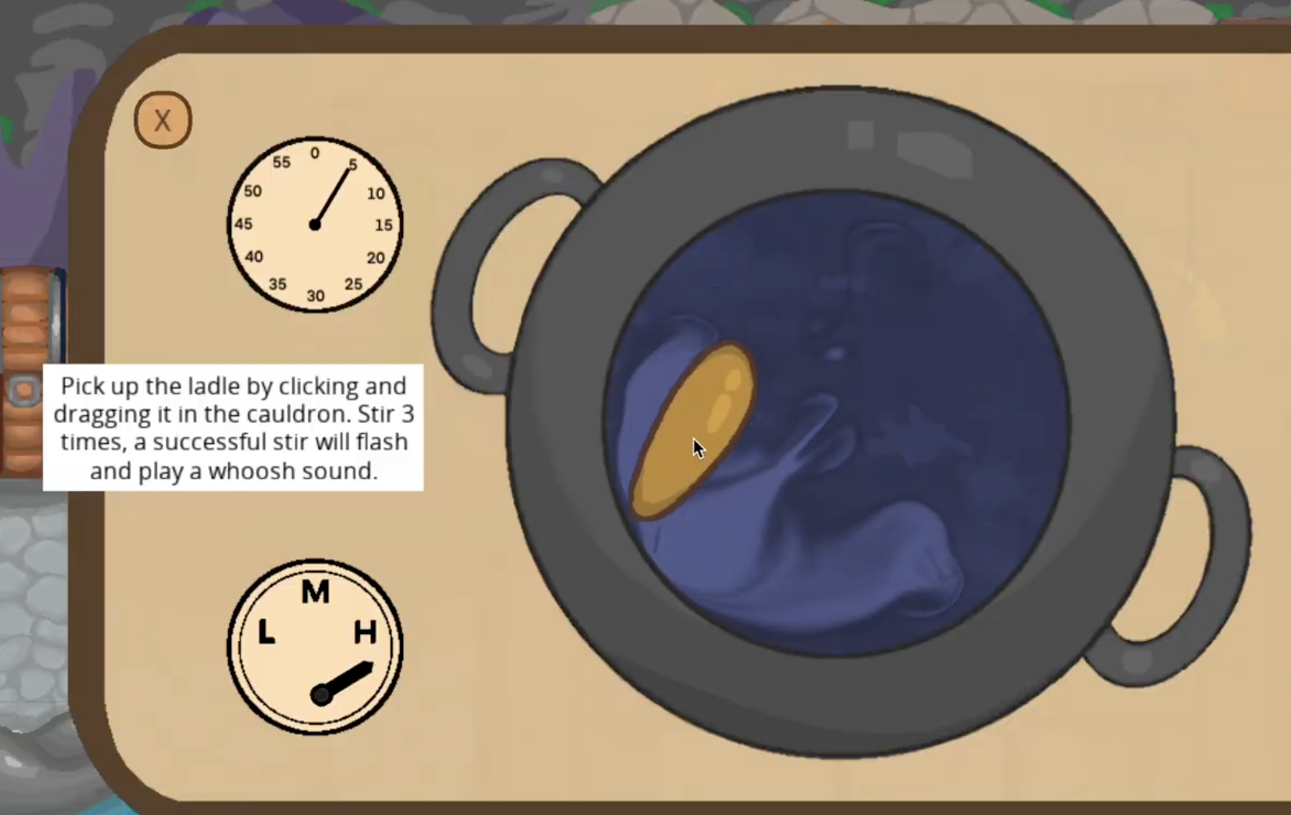
3. Wait 5 seconds by watching the timer that starts ticking once you start the potion making process (turning on the heat).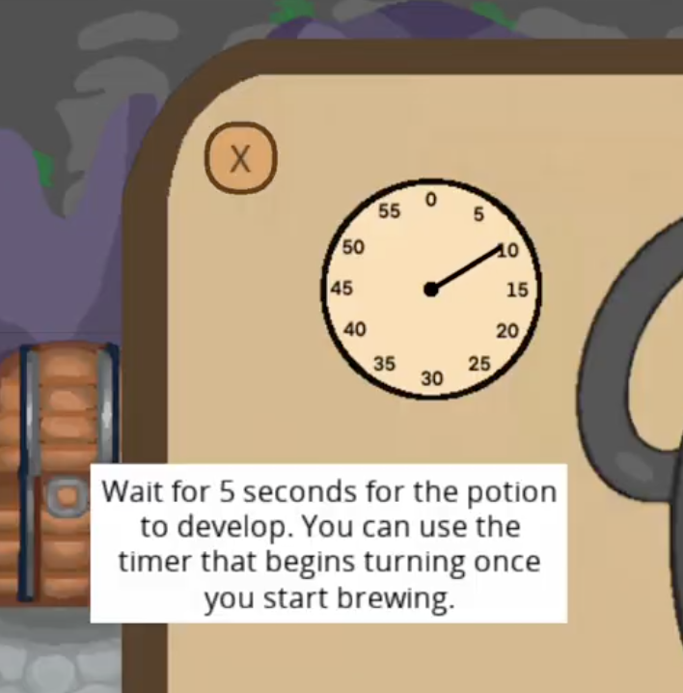
4. Now you can bottle the potion by left clicking on the potion bottle and letting go, then move your mouse over the cauldron and left click again. Make sure you do the steps quickly enough, the closer you follow the recipe the closer the potion color will be to the recipe book to the potion of harming. If you take too long, the potion may become a “failed potion”. There are 5 qualities of potions, Basic, Mellow, Refined, Opulent and Superior that have varying stats based on how well you made the potion.

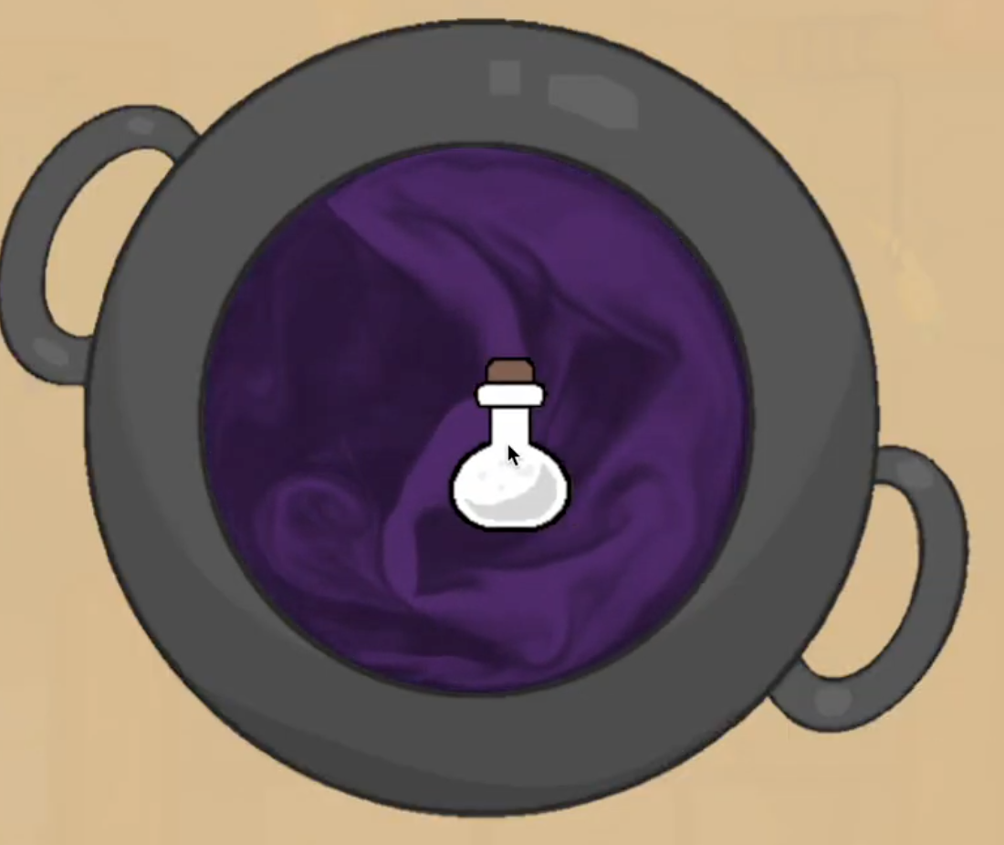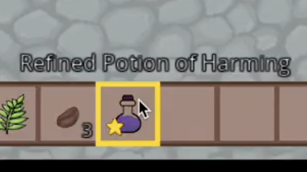

1. Enter the deep forest and approach the tree enemy. Select the potion of harming in your inventory. Get close enough to it and aim your mouse at the enemy and click to throw.  
   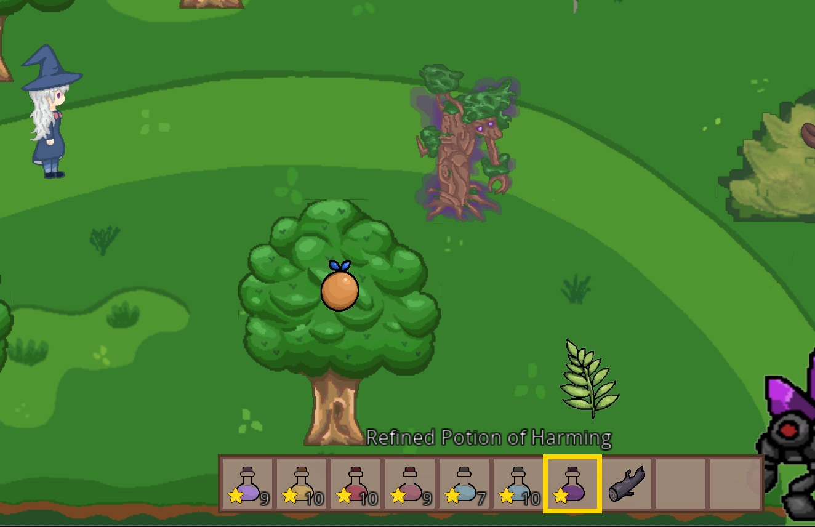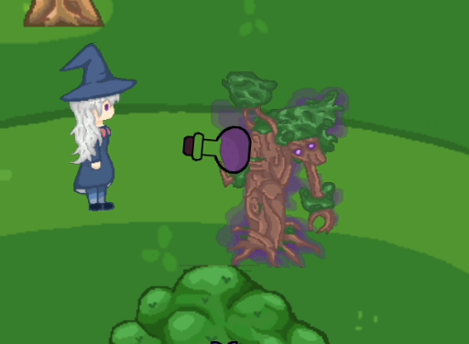
2. When the enemy takes damage, it will flash red. Similarly if the player takes damage they will also flash red. (The enemy is hugging the player right now but you can see the red behind the tree). Notice the health decease in the health bar at the bottom right.

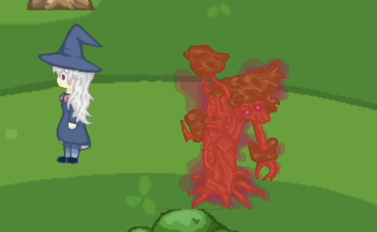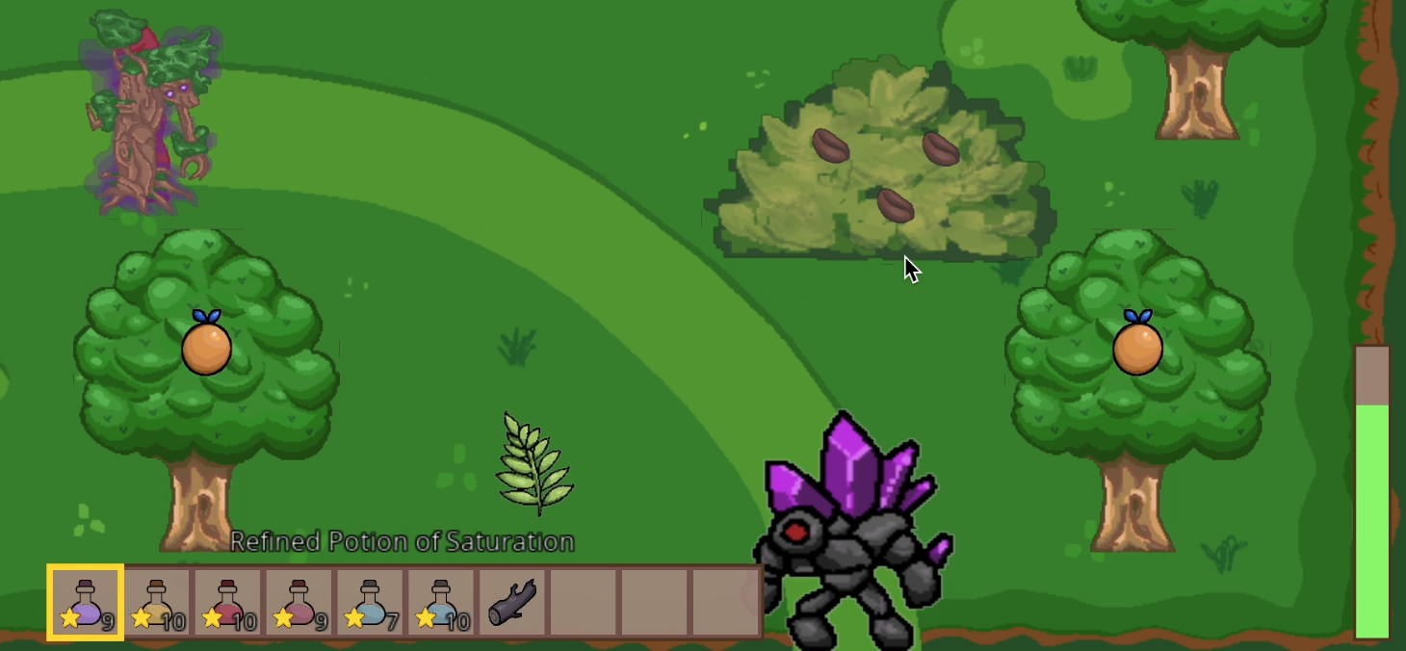

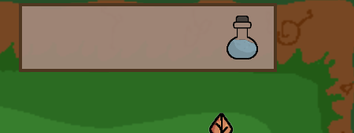

1. You can consume a potion by right-clicking the icon in inventory. It will also appear in active effects bar

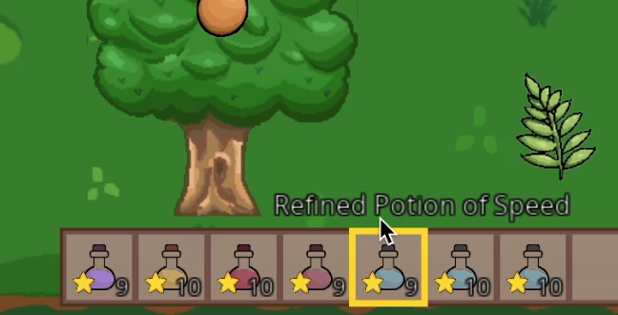

1. Check out our bridge by walking across it, and try out walking along the bridge. The bridge boundaries are defined by a mesh, so that the player bounding box cannot intersect with the top and bottom. of the bridge as defined by the white mesh space illustrated below

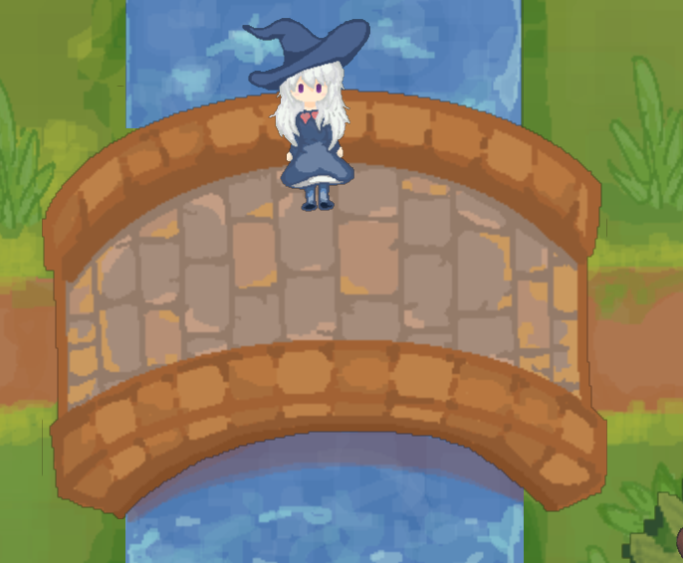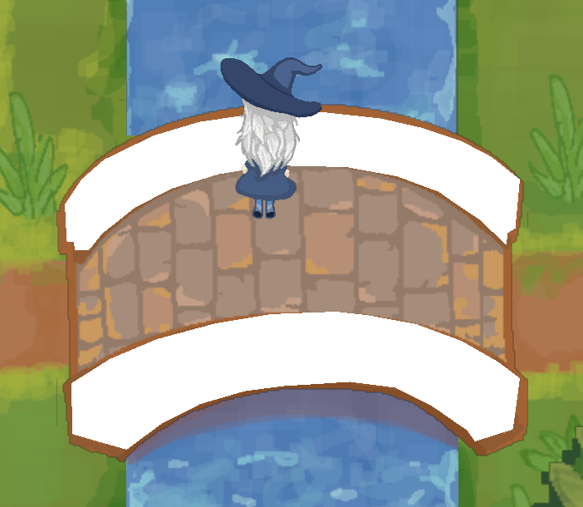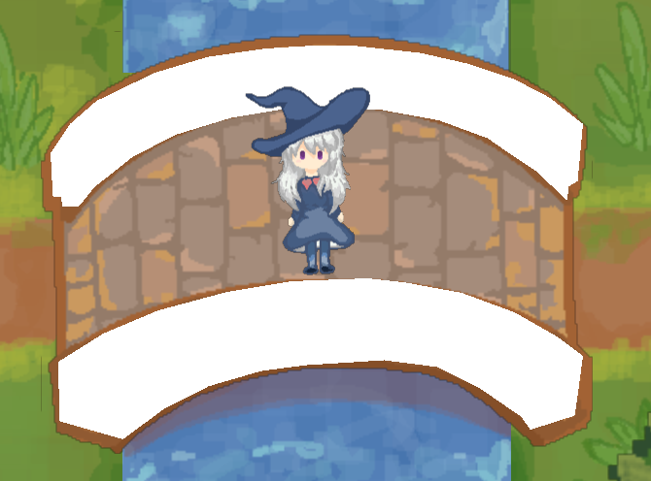

1. You can see your player health with the green bar at the bottom right of the screen, and when you consume a potion, it will be displayed in the top right effect box. You can delete an item in inventory by pressing Shift + Left Click.

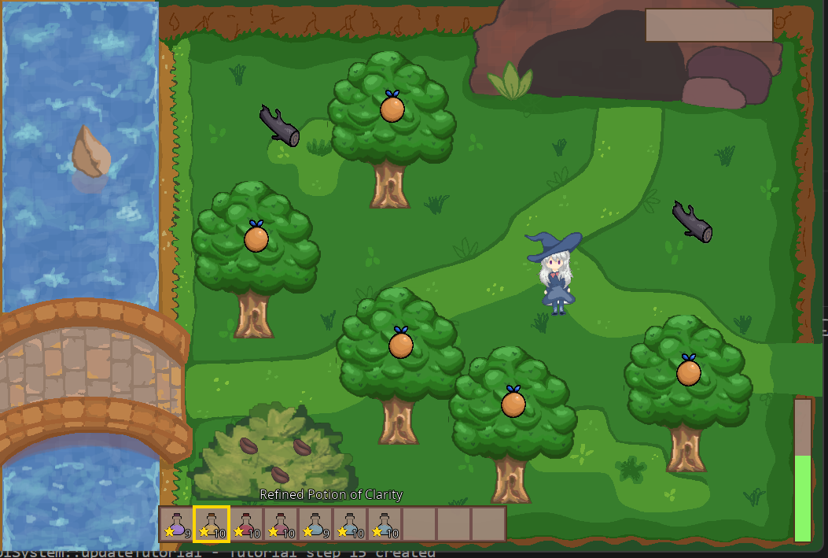

1. Please refer to the recipe book for the steps and ingredients for Potion of Saturation. Please make this potion and go near the desert guardian, press F to give potion to the guardian to unlock the biome!

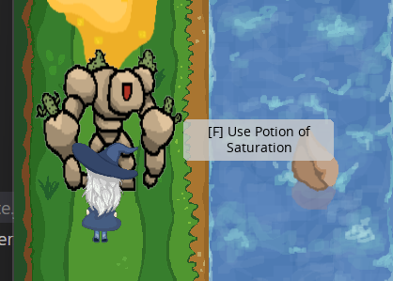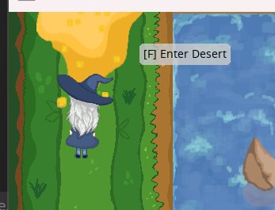

1. All biomes are unlocked in the same way as described in unlocking the desert step by giving the corresponding biome-unlocking potion to a guardian. The guardian will move away to allow permanent entry into the biome. Take your time and explore around our 4 biomes (Forest, Desert, Shroomland, and Crystal Mine)!
2. A game_state.json file is included at the end of this document with all the potions you need to complete the game. To complete the game, you have to unlock all the biomes and make the master potion (Potion of Rejuvenation), and insert it into the Master Potion Pedestal.

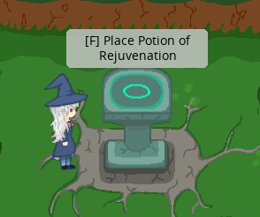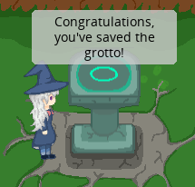

1. Exit the game with ESC, rerun the game and the inventory should be persisted, so the items you collected in the game state remain.

(replace game_state.json file under data/game_states/v2 with this to get all potions required to complete the game)

{

"inventories": [

{

"capacity": 10,

"items": [

{

"amount": 10,

"is_ammo": false,

"potion": {

"color": [

171.0,

135.0,

215.0

],

"duration": 189381,

"effect": 10,

"effectValue": 1.3960000276565552,

"quality": 0.6644444465637207

},

"saved_id": 8,

"type": "potion",

"type_id": 0

},

{

"amount": 10,

"is_ammo": true,

"potion": {

"color": [

208.0,

173.0,

106.0

],

"duration": 95102,

"effect": 12,

"effectValue": 2.4447500705718994,

"quality": 0.6650000214576721

},

"saved_id": 10,

"type": "potion",

"type_id": 0

},

{

"amount": 10,

"is_ammo": false,

"potion": {

"color": [

177.0,

83.0,

99.0

],

"duration": 0,

"effect": 11,

"effectValue": 25.45600128173828,

"quality": 0.5960000157356262

},

"saved_id": 12,

"type": "potion",

"type_id": 0

},

{

"amount": 10,

"is_ammo": false,

"potion": {

"color": [

169.0,

107.0,

122.0

],

"duration": 18379,

"effect": 13,

"effectValue": 3.351874828338623,

"quality": 0.6337499618530273

},

"saved_id": 14,

"type": "potion",

"type_id": 0

},

{

"amount": 10,

"is_ammo": false,

"potion": {

"color": [

199.0,

176.0,

119.0

],

"duration": 90000,

"effect": 2,

"effectValue": 2.5,

"quality": 0.6000000238418579

},

"saved_id": 6165,

"type": "potion",

"type_id": 0

},

{

"amount": 10,

"is_ammo": true,

"potion": {

"color": [

107.0,

82.0,

158.0

],

"duration": 0,

"effect": 4,

"effectValue": 68.0,

"quality": 0.6000000238418579

},

"saved_id": 6169,

"type": "potion",

"type_id": 0

},

{

"amount": 10,

"is_ammo": false,

"potion": {

"color": [

157.0,

123.0,

147.0

],

"duration": 0,

"effect": 3,

"effectValue": 22.0,

"quality": 0.4000000059604645

},

"saved_id": 6174,

"type": "potion",

"type_id": 0

}

],

"owner_type": "player",

"saved_id": 5

},

{

"capacity": 2147483647,

"items": [],

"owner_type": "cauldron",

"saved_id": 1054

}

],

"player_state": {

"active_effects": [],

"consumed_potion": false,

"cooldown": 0.0,

"damage_cooldown": 0.0,

"defense": 1.0,

"effect_multiplier": 1.0,

"health": 60.0,

"load_position_x": 651.5596313476563,

"load_position_y": 348.278564453125,

"name": "Madoka",

"speed_multiplier": 1.0

},

"recipe_book_index": 7,

"screen_state": {

"biome": 0,

"from_biome": 1,

"killed_enemies": [],

"tutorial_state": 17,

"unlocked_biomes": []

}

}